- Introduction
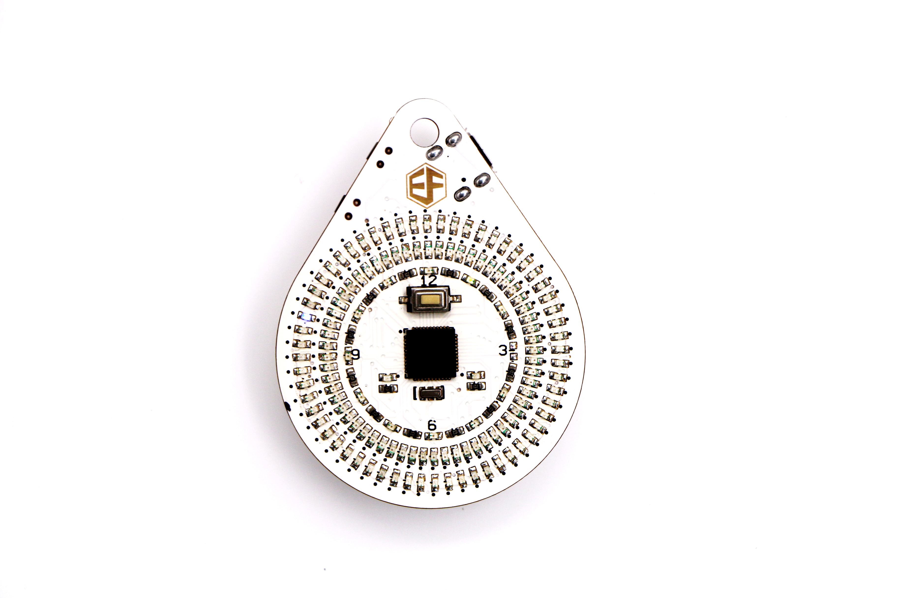
FreaksDial is a completely open-source pocket watch that consists of MEGA32U4 controller, 134 LED displays, two side buttons, a USB port and a charging circuit for the button cell through USB port. Press and hold the button on the top, one of LED displays in the inner array will flicker. Adjust the hour indication by pressing the button on the bottom. Press the button on the button again, one of LED displays in the middle array will flicker. Continue to adjust the minute indication by pressing the button on the bottom. Press the button on the top again, and FreaksDial time will return to indicate.

Press and hold the button on the bottom, three LED displays right above hour indicator 12 will be turned on. Press the button on the top, the outer array of LED displays will circulate rapidly and the middle LED displays will circulate slowly. Press the button on the top again, the circulating LED will pause. Press the button on the top, LED displays will circulate again. Press the button on the bottom again, FreaksDial time will return to indicate.

Since FreaksDial is open-source, it’s far more powerful than above applications. Users can make interesting and creative wheel of fortune.

2.FreaksDial PCB Soldering
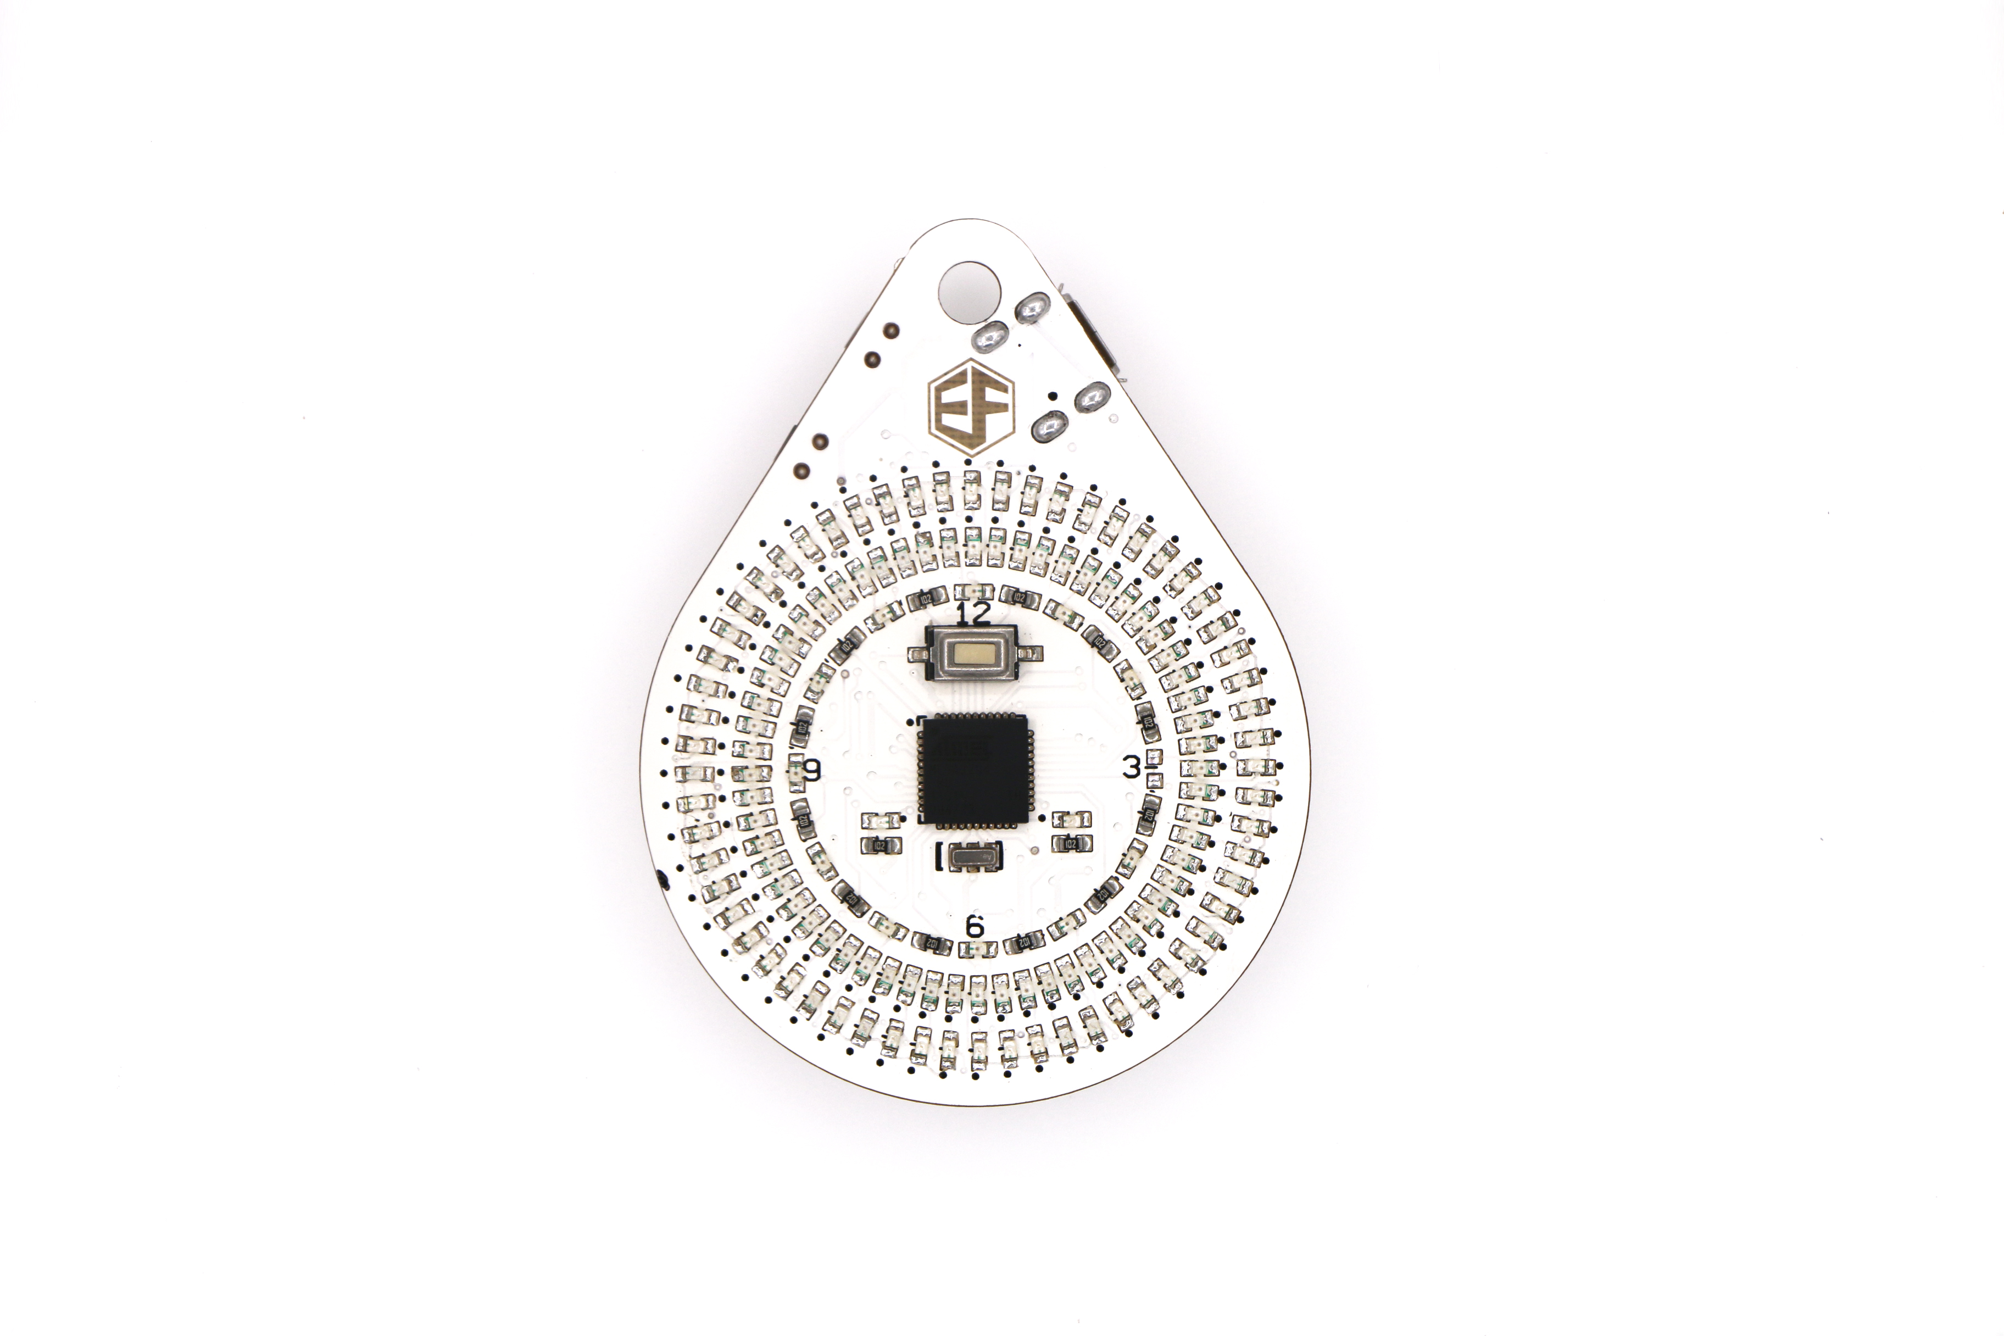
Pic 1 FreaksDial soldering on the top
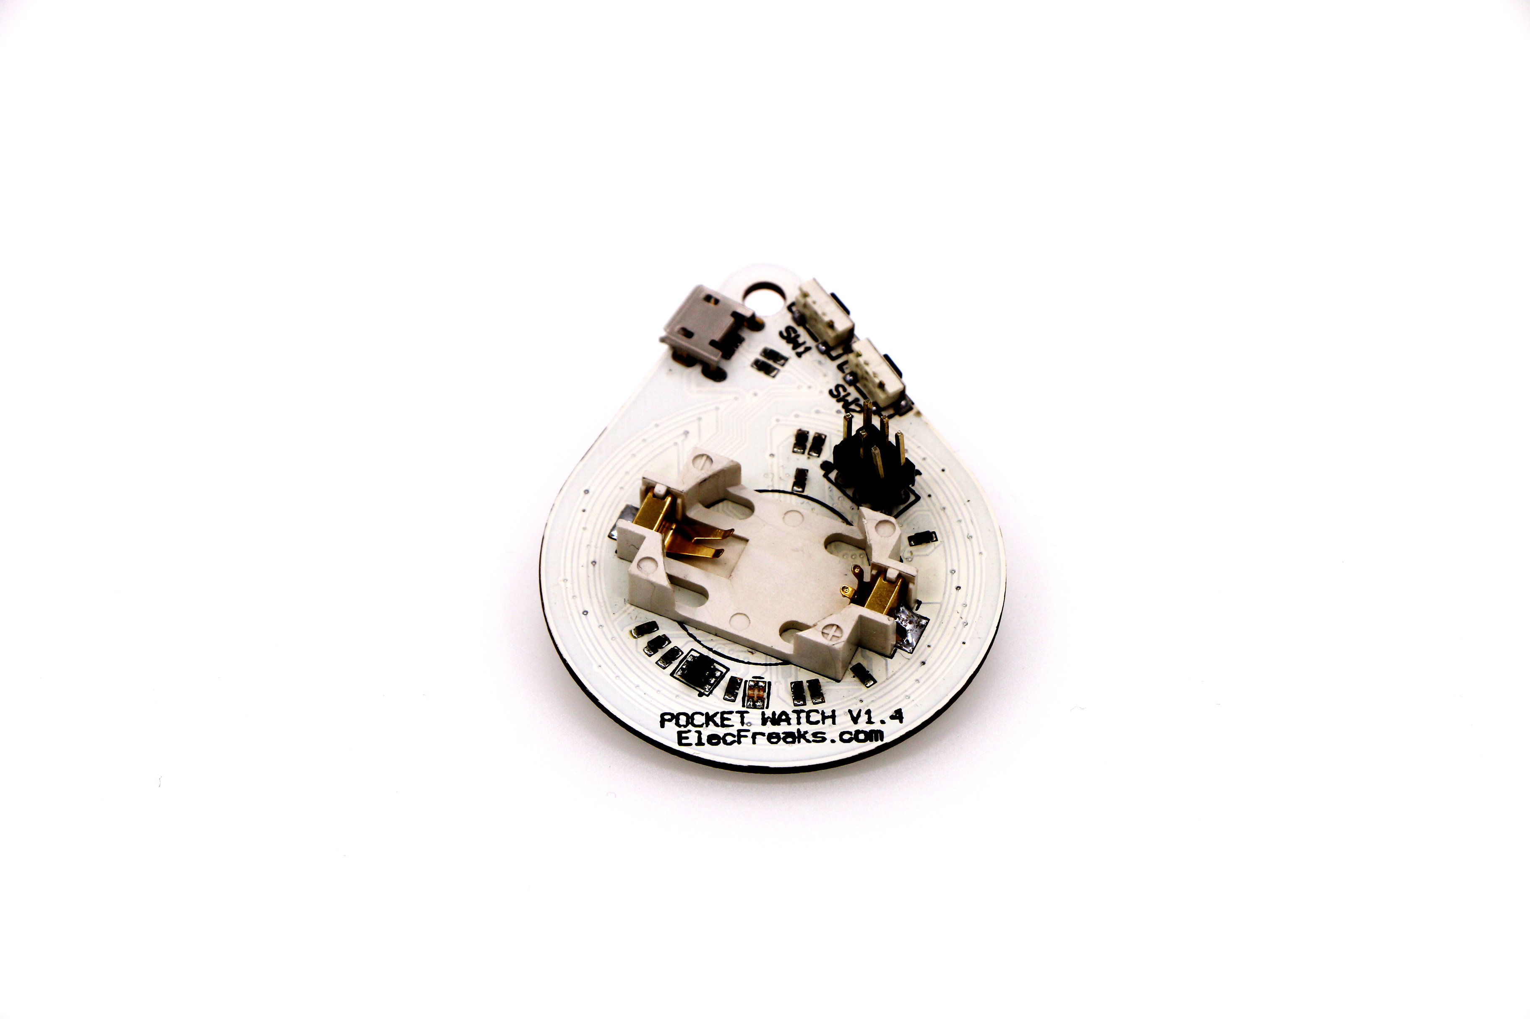
Pic 2 FreaksDial soldering on the bottom

3.Test
3.1 Software
（1）FreaksDial testing code
（2）Arduino IDE
3.2 Testing code burning
Start downloading FreaksDial_SourceCode.zip by clicking http://www.elecfreaks.com/estore/download/FreaksDial_SourceCode.zip, unzip it and run FreaksDial test to start compiling and burning process. Burning steps are shown below.

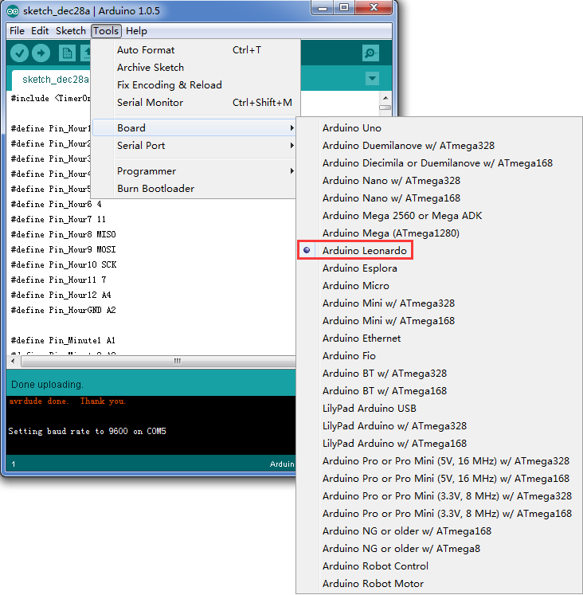
Pic 3 Select Arduino Leonardo

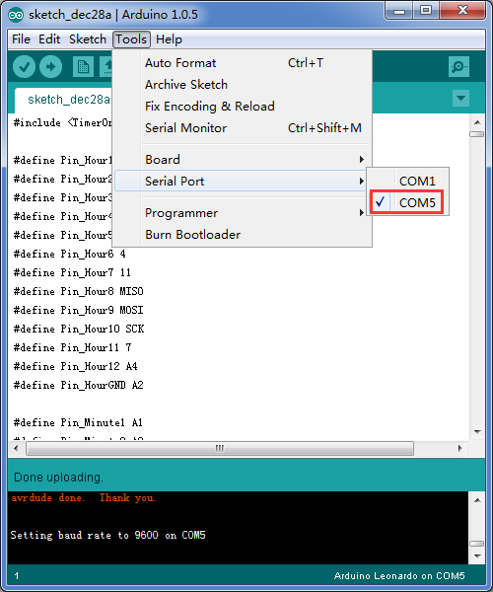
Pic 4 Select Serial Port
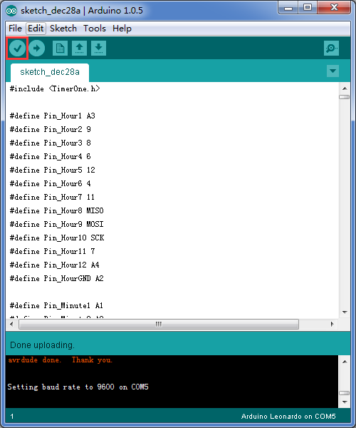
Pic 5 Click Verify

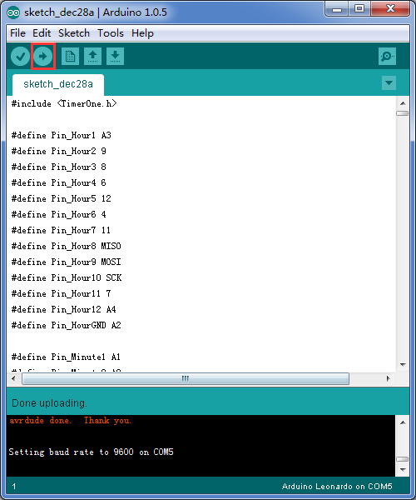
Pic 6 Click Upload

3.3Test Procedure
When the burning process is completed, put CR2032 3V button cell in FreaksDial and the out array LED displays will circulate at one second’s interval, the middle LED displays at one minute’s interval and the inner LED displays at one hour’s interval.

Press and hold the button on the top, one of LED displays in the inner array will flicker. Adjust the hour indication by pressing the button on the bottom. Press the button on the button again, one of LED displays in the middle array will flicker. Continue to adjust the minute indication by pressing the button on the bottom. Press the button on the top again, and FreaksDial time will return to indicate.

Press and hold the button on the bottom, three LED displays right above hour indicator 12 will be turned on. Press the button on the top, the outer array of LED displays will circulate rapidly and the middle LED displays will circulate slowly. Press the button on the top again, the circulating LED will pause. Press the button on the top, LED displays will circulate again. Press the button on the bottom again, FreaksDial time will return to indicate.

4.Version

Version | Note | Date
V1.6 | Early version | 2016.03.30

5. Contact
For more information, please visit: http://www.elecfreaks.com

